Ivan Henry aka Moose
- Plunderer
- Member

- 486 posts
- Gender:Male
- Location:tampa, fl
- Interests:Bicycles
Travel
Wine
Beer
Good Food
Pizza!
Pirate Stuff
Design
(IP: 71.41.81.2) ·
Posted April 10, 2009 · Report post
Just wondering if anyone has ever seen a reference to those stripey stockings I've seen people associate with pirate attire. I have yet to see aperiod drawing or a written reference to these. Any help?

- Quote
- Edit

michaelsbagley
- Smells Like Wet Sheep
- 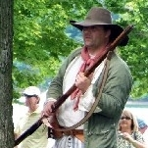
- Moderator

- 2,548 posts
- Gender:Male
- Location:Columbus, Ohio
- Interests:Mostly into GAoP, but starting to develop more Buccaneer era stuff for re-enacting as well. Generally I do re-enact both piratical/nautical and other impressions from the period. I am focusing on more "common" impressions from the period (i.e. average sailor/pirate, rank and file Red Coat, early Colonial huntsman, etc.)
(IP: 199.230.203.254) · ·
Posted April 10, 2009 · Report post
Mooseworth said:
Just wondering if anyone has ever seen a reference to those stripey stockings I've seen people associate with pirate attire. I have yet to see a period drawing or a written reference to these. Any help?
The short answer is they are not historically correct that I know of.
There have been a few really good in depth discussions about them over the years, I'll try and dig the links up and post them for you. If memory serves me well, there was one period image that seemed to depict vertical striped socks... But no evidence of the horizontal striped stocking so popular amongst the Rennie pirate scene.

- Quote
- Edit
- Options

michaelsbagley
- Smells Like Wet Sheep
- Moderator

- 2,548 posts
- Gender:Male
- Location:Columbus, Ohio
- Interests:Mostly into GAoP, but starting to develop more Buccaneer era stuff for re-enacting as well. Generally I do re-enact both piratical/nautical and other impressions from the period. I am focusing on more "common" impressions from the period (i.e. average sailor/pirate, rank and file Red Coat, early Colonial huntsman, etc.)
(IP: 199.230.203.254) · ·
Posted April 10, 2009 · Report post
Well I did a search through both the "Captain's Twill" and "Thieve's Market" sections of the pub, and I couldn't find the thread I seem to recall. Maybe the discussion happenned on another pirate forum I am on? Sorry I couldn't be of more help or provide more solid evidence.

- Quote
- Edit
- Options

Ivan Henry aka Moose
- Plunderer
- Member

- 486 posts
- Gender:Male
- Location:tampa, fl
- Interests:Bicycles
Travel
Wine
Beer
Good Food
Pizza!
Pirate Stuff
Design
(IP: 71.41.81.2) · ·
Posted April 10, 2009 · Report post
michaelsbagley said:
Well I did a search through both the "Captain's Twill" and "Thieve's Market" sections of the pub, and I couldn't find the thread I seem to recall. Maybe the discussion happenned on another pirate forum I am on? Sorry I couldn't be of more help or provide more solid evidence.
Thanks! I've been dong a lot researching lately, trying to build a good kit and as you've noticed as well, failed to see any evidence either way. Could they be a bigger faux pas than bucket boots on a historically correct effort?

- Quote
- Edit
- Options

michaelsbagley
- Smells Like Wet Sheep
- Moderator

- 2,548 posts
- Gender:Male
- Location:Columbus, Ohio
- Interests:Mostly into GAoP, but starting to develop more Buccaneer era stuff for re-enacting as well. Generally I do re-enact both piratical/nautical and other impressions from the period. I am focusing on more "common" impressions from the period (i.e. average sailor/pirate, rank and file Red Coat, early Colonial huntsman, etc.)
(IP: 199.230.203.254) · ·
Posted April 10, 2009 (edited) · Report post
Mooseworth said:
Thanks! I've been dong a lot researching lately, trying to build a good kit and as you've noticed as well, failed to see any evidence either way. Could they be a bigger faux pas than bucket boots on a historically correct effort?
You're most welcome for the help (for all that it was)...
As for your question, it is very subjective.... One person, may not care about boots but get bent right out of shape about stripey socks, another person might hate boots but be more than willing to overlook stripey socks...
Personally, I'd be more willing to overlook the socks than the boots... But I'm only one person and not one of much consequence, specially with regards to the event you are prepping for. Contacting one of the host Crew (Blackbeards Crew) might get you the best answers on tolerance levels.
Edited April 10, 2009 by michaelsbagley

- Quote
- Edit
- Options

Fox
- Old Twillian
- Moderator

- 2,564 posts
- Gender:Male
- Location:Beautiful lush Devon, England
- Interests:Nautical history of the 16-18th centuries and living history based thereon.
Shooting pirates.
(IP: 86.162.27.245) · ·
Posted April 10, 2009 · Report post
IIRC there were a small number of pictures of striped stocking from 1740ish onwards, and the earliest anyone could find was the Williamsburg fan of, I think, 1739 (courtesy of Blackjohn). Even after that date there were very few depictions.
With that in mind I'd not agree that striped hose were right by any means (if you're really trying to get it right then avoid them), but probably less of an issue for me than bucket boots.

- Quote
- Edit
- Options

Ivan Henry aka Moose
- Plunderer
- Member

- 486 posts
- Gender:Male
- Location:tampa, fl
- Interests:Bicycles
Travel
Wine
Beer
Good Food
Pizza!
Pirate Stuff
Design
(IP: 65.32.145.42) · ·
Posted April 16, 2009 · Report post
Anyone have a reference picture?

- Quote
- Edit
- Options

Gentleman of Fortune
- Dread Pyrate
- Member

- 1,456 posts
- Gender:Male
- Location:Germany... Franconia (northern Bavaria)
- Interests:I *used* to be an environmental scientist, until I married a DoDDs teacher in 1997. Since then, I have been living in, and traveling around, Europe (First the UK, now Germany).
My hobbies are all the "usual suspects" for those interested in re-enacting and Golden Age of Piracy stuff.... but I have drifted away from the pirate scene as my location and young family don't allow for any more than "virtual" pirate participation. Besides Piracy, I am into Reverend Guitars and Vintage Corvettes.
(IP: 93.209.217.220) · ·
Posted April 17, 2009 · Report post
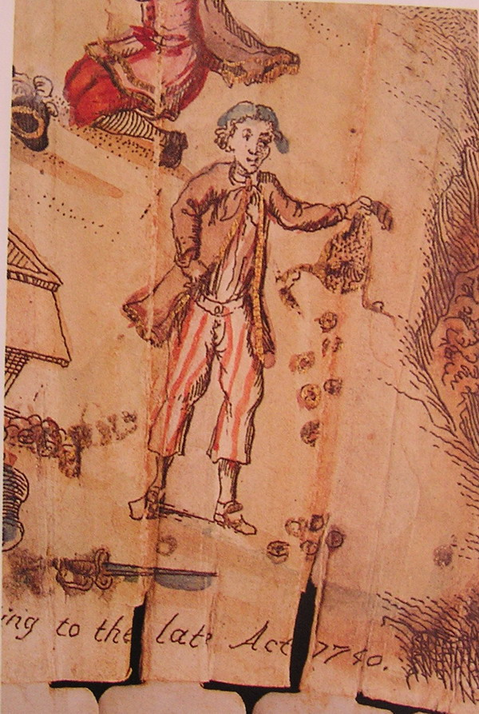
1740

- Quote
- Edit
- Options

RustyNell
- Pyrate Captain
- Member

- 726 posts
- Location:Fort Myers and Key West, Florida
- Interests:Member of The Bone Island Buccaneers - Pressed into service as ships shanty and distiller of spirits.<br /><br />I'm a singer and songwriter with a love of folk music, especially nautical songs (my grandfather was a Navy man and I myself served as a Quartermaster in the USN for 6 years)<br /><br />I've been acting since I was 7, my mother was a professional actress and singer and got me involved in the theater at an early age. RE-ENacting is a fairly new thing for me. I have a few years under my belt but am working my way towards history (PC) I've always had a great love for historical fiction. I truly love being able to create my own persona and more so I love being able to weave her story into the drama of history. What fun, What a way to learn!! Thats the major reason why I'm drawn to re-enacting, I learn so much about history and so much about myself through my characters....not to mention I like being a big KID playing dress up, and sharing in all the laughter with my wacky friends!!! <br /><br /><br />.
(IP: 66.32.119.233) · ·
Posted April 18, 2009 · Report post
Could those lines just as well be knitting ribs instead of color? A thought... had the socks been hand knitted with several rows of pearl then several rows of knit they they might look somewhat striped. I've seem wool sock in cable knit like a sweater, any thoughts on those?

- Quote
- Edit
- Options

Dutchman
- Has anyone seen my cousin?
- Admin

- 1,773 posts
- Gender:Male
- Location:tidewater virginia
(IP: 208.210.219.131) · ·
Posted April 18, 2009 · Report post
ahoy mooseworth,
just wandered across this thread. as far as the blackbeard festival goes, if you are attending as general public- wear what you like and enjoy yourself. if you are a performing crew the boots should stay at home and we really don't mind striped socks, but prefer solids.
If i can help with anymore prefestival questions, please don't hesitate to ask and be sure to track me down when you get there. I'll be in camp by thursday.
-dutch

- Quote
- Edit
- Options

blackjohn
- Iron Age Hero Lost at Sea
- 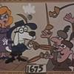
- Member

- 3,745 posts
- Gender:Male
- Location:Columbia, Md
- Interests:Stuff... and junk.
(IP: 173.69.179.46) · ·
Posted April 19, 2009 · Report post
Mooseworth said:
Anyone have a reference picture?
Yeah, as Foxe says, it is from a fan in the DeWitt Wallace Decorative Arts Museum. If I recall properly, the figure in question was not a westerner, but a captive of some foreign nationality. But don't quote me on that.
Back when we were originally debating this image, like Rusty Nell, I suggested that the stripes could just as easily be an artistic convention, i.e., someone trying to show shading. I seem to recall someone with artistic expertise debated the opposite. I wasn't convinced. Ymmv.

- Quote
- Edit
- Options

RustyNell
- Pyrate Captain
- Member

- 726 posts
- Location:Fort Myers and Key West, Florida
- Interests:Member of The Bone Island Buccaneers - Pressed into service as ships shanty and distiller of spirits.<br /><br />I'm a singer and songwriter with a love of folk music, especially nautical songs (my grandfather was a Navy man and I myself served as a Quartermaster in the USN for 6 years)<br /><br />I've been acting since I was 7, my mother was a professional actress and singer and got me involved in the theater at an early age. RE-ENacting is a fairly new thing for me. I have a few years under my belt but am working my way towards history (PC) I've always had a great love for historical fiction. I truly love being able to create my own persona and more so I love being able to weave her story into the drama of history. What fun, What a way to learn!! Thats the major reason why I'm drawn to re-enacting, I learn so much about history and so much about myself through my characters....not to mention I like being a big KID playing dress up, and sharing in all the laughter with my wacky friends!!! <br /><br /><br />.
(IP: 65.41.26.47) · ·
Posted April 19, 2009 · Report post
Only reason I might agree with blackjohn's comment above is that the rest of the picture has color and the pant stripes are painted. I would think the artist would paint those as well if they were alternating colors like he did the pants. just my opinion.

- Quote
- Edit
- Options

Shipwreck John
- Plunderer
- Member

- 462 posts
- Gender:Male
- Location:Thomasvillle Ga.
- Interests:Fishing, snorkeling, some scuba, artifact searching, sightseeing
(IP: 64.39.148.148) · ·
Posted April 19, 2009 · Report post
They must be authentic, cause Captain Bogg wears em.
Not really sure if they are, but it probably won't stop me from wearing them as I dress more hollywood than GOP anyway

- Quote
- Edit
- Options

Dutchman
- Has anyone seen my cousin?
- Admin

- 1,773 posts
- Gender:Male
- Location:tidewater virginia
(IP: 208.210.219.131) · ·
Posted April 19, 2009 · Report post
just my two cents. the artist does use plack lines to mark textures and shadowing. look at the tops of the socks on the lower man, various times on the jackets and on the crate on the left side. has anyone ever contacted the museum for their take on it?

- Quote
- Edit
- Options

callenish gunner
- Scourge o' the 7 Seas
- Member

- 2,138 posts
- Gender:Male
- Location:Pennsylvania mountains north of Clarion
- Interests:The Callenish gunner has just hoved into view looking for safe anchorage in these waters... purveyor of bladed and flintlock weaponry also leather accessories ..........painter of portraits and period scenes by avocation I'm getting my armoury business underway and will be doing as many festivals as I can ...right now along the east coast or great lakes
(IP: 98.21.68.19) · ·
Posted April 19, 2009 · Report post
however the other lines used only went in sporadic areas and never all the way across any item of clothing where the ones on the stocking on the upper figure do cross the entire leg ...why couldn't they be striped???

- Quote
- Edit
- Options

Dutchman
- Has anyone seen my cousin?
- Admin

- 1,773 posts
- Gender:Male
- Location:tidewater virginia
(IP: 208.210.219.131) · ·
Posted April 19, 2009 (edited) · Report post
e gads gunner! i hope your not poluting wee hammishs mind with all this dribble of striped socks. why next thing you know he'll be wearing straw tricorns, bucket boots and drinking out of glass bottomed tankards.
just kiddin mate
there is really not enough to go on. it could or could not be striped or as nell suggests a type of weave. one of those mysteries of life i guess.
by the way, auntie grace and dutch get dibs on spoiling the wee one at the festival!
Edited April 19, 2009 by bbcddutchman

- Quote
- Edit
- Options

Gunpowder Gertie
- Pyrate Captain
- Member

- 519 posts
- Gender:Female
- Location:Vancouver
(IP: 24.86.20.179) · ·
Posted April 19, 2009 (edited) · Report post
callenish gunner said:
however the other lines used only went in sporadic areas and never all the way across any item of clothing where the ones on the stocking on the upper figure do cross the entire leg ...why couldn't they be striped???
Having been a professional artist, and more than familiar with types of shading, I would say that the artist intended for the stripes on the lower leg of the kneeling person to be stripes. The stripes go all the way around the leg, yet they are separate. If the artist intended to show shadow of the body over the leg, the stripes may or may not go all the way "around" the leg- but they would most certainly be closer together to indicate a denser shadow. Also, there would likely be more stripes at the bottom of the leg (the shin) to indicate gradation of tone, and a darker shadow again as it touches the ground.Also note, on the other body that the shading stripes are short and choppy, and are used to denote shape, form and structure. The stripes on the leg do none of these things, and are in my opinion there merely to indicate a pattern.I would also say that the colour of the stocking stripes are black, as red was used to denote pants stripes,and the pants themselves and gold/brown wash to indicate coat colour. That wouldn't be necessary to add a wash if if the stripes were black to begin with.
Edited April 19, 2009 by Gunpowder Gertie

- Quote
- Edit
- Options

Ivan Henry aka Moose
- Plunderer
- Member

- 486 posts
- Gender:Male
- Location:tampa, fl
- Interests:Bicycles
Travel
Wine
Beer
Good Food
Pizza!
Pirate Stuff
Design
(IP: 71.41.81.2) · ·
Posted April 20, 2009 · Report post
There it is! I have seen this before, but didn't take note of the stripe socks. Nice!
Gentleman of Fortune said:

1740

- Quote
- Edit
- Options

Ivan Henry aka Moose
- Plunderer
- Member

- 486 posts
- Gender:Male
- Location:tampa, fl
- Interests:Bicycles
Travel
Wine
Beer
Good Food
Pizza!
Pirate Stuff
Design
(IP: 71.41.81.2) · ·
Posted April 20, 2009 · Report post
Thanks! I appreciate it!
bbcddutchman said:
ahoy mooseworth,
just wandered across this thread. as far as the blackbeard festival goes, if you are attending as general public- wear what you like and enjoy yourself. if you are a performing crew the boots should stay at home and we really don't mind striped socks, but prefer solids.
If i can help with anymore prefestival questions, please don't hesitate to ask and be sure to track me down when you get there. I'll be in camp by thursday.
-dutch

- Quote
- Edit
- Options

Calico Jack
- Ship's Master
- Member

- 126 posts
- Location:Port o' Halifax, New Scotland...
(IP: 198.166.214.5) · ·
Posted July 29, 2009 · Report post
I'm putting the large number of researchers here to use.
I've had some F&I period reenactors locally bring up the debate that any depiction of vertically-striped stockings in that period are used to show the individual as unschooled and a "country bumpkin" for satirical purposes. I've attempted to demonstrate that most images showing such stockings as "country bumpkin" are 1790s, but as for finding British Navy/Merchant sailors wearing vertically striped stockings before that, most of my evidence is circumstantial.
Both in images and written text, the early 1700s references to striped stockings all seem to point to them being "exclusively" Continental. Whether the references from the "Macaroni Club" of the 1770s, or the images of clothiers in the 1740s displaying their mastery of Continental fashion, the British press seem to regard vertical stripes as a purely Continental thing.
That said, yes we well know that the British mariners of the period immediately following the GAoP were a rather multinational bunch. The likelihood of sailors wearing "foreign" fashion is rather good, but likelihood is not proof. It merely shows a possibility, even a probability, but by no means a certainty.
What other documentation - text or image - do folks know of for the very end of the GAoP which might support [or for that matter disprove] the wearing of vertically striped stockings by British sailors [regardless of their actual nation of origin]? What stockings, as it were, might Ned Low's crew have worn?
Anyone know of some off the cuff?

- Quote
- Edit
- Options

Salty
- Dread Pyrate
- Member

- 1,012 posts
- Location:back in the mountains of westren pa...good to be back home
- Interests:maker o pots, tankards, and rum jugs. the natural world as it be and history that was not written by the winners.
(IP: 98.21.68.70) · ·
Posted July 29, 2009 (edited) · Report post
I am not sure if this will prove or disprove any one's questions on striped, vertical or otherwise. But here is one site i have used when reeasrching historical knitting for the 18 th centurey.
http://www.marariley.net/knitting/knitting.htm
i have NO idea how to post so the links work anymore, but there is one site.
Ye Ship's Potter, turned fiber rat.
salty
PS in talking to a woman that handles historical yarns from the UK they are coming up with more documentation all the time in the museums.
PPS Dutch how could gunner polute the wee laddie's mind when the likes of cousin robbie be about :))
Edited July 29, 2009 by Saltypots

- Quote
- Edit
- Options

oderlesseye
- Scourge o' the 7 Seas
- Member

- 2,126 posts
- Gender:Male
- Location:San Diego, Ca. (North Park) me cove !
- Interests:Oderlesseye is a mutinous two bit sand dollar with a thirst for adventure. Sailing on tall ships, firing black powder weapons, and sword fighting.. I most love to entertain the public in piratical skit presentations that involve all of the above. My name is befitting of my position on board as that of the look-out. Some ask what’s the meaning of the name Oderlesseye...It is simple really.. When Eye am aloft, ye can’t smell me...But it’s spelled wrong some exclaim! Hey now! What pirate can spell? - is my retort!
I have been an active member of the pirate community since 2005. I consider myself a fan of living history in the Golden Age of Piracy. As a child I , like the lot of ye, loved the old time pirate movies with Errol Flynn and Douglas Fairbanks. Long live Long John Silver !
Inspired by them, Eye created a Pirate Ninja Movie called "Treachery and a Dead Mans Promise" Available on YouTube.
Being a pirate, as it turns out, is multi-dimensional. For me, a lifestyle has been carved out of it. There is a six foot tall skeleton pirate in a make shift hide out called Dead Mans Cove behind my house. The walls are painted giving the impression you are in a sea cave. There is a mural of a pirate coming ashore in a long boat at the mouth of the cove. Believe me, it is a great place to enjoy rum now and again!
Exploration into all things piratical have led me to being an attempted escapee from the Governors noose to impersonating a judge in the Anne Bonnie and Mary Read trial held in Pirates In Paradise.. As Oderlesseye, my one on one impression to patrons is as one whom barley escaped the flames of the ship we took when the powder magazine blew with the booty in me hands from the Captains quarters.. The tale explains the soot on me face, the tattered clothing, and the burnt tricorn, as I hand out a gold coin or two. I hate them plastic ones and I know kids appreciate the metal coins even more so.
When an event is slated for a historical time line presentation to the public, I do not do these things mentioned above. Rather, I share about what is a grape shot or how a flintlock works. I ware clothing that is more closely representing the era in these cases. I am still updating me togs (Period Kit) as I learn more thru fellow pirates and sources like the Pyracy Pub.
So far, there have been many exciting moments of adventure the world of PIRACY has afforded me. From standing on a bar top with Pirates Charles singing to me in New Orleans to shooting cannons ( Ships Guns for you PC Pirates!), on the tall ship Spirit of Dana Point. Cheers from a crowd during a show as last man standing on the Treasure chest proclaiming to an excited crowd ITS MINE! THE BOOTY IS MINE ! YARR ! ~ These things and the notoriety that comes with being a pirate has me hooked! Whats More Is the greater bonds of friendships that have been forged with those whose course finds me at such events, sharing the same love and passion of the Life within the pirate/reenactment community. To Them Eye take me hat off and offer a tot of Rum! Cheers mates!
(IP: 72.220.190.137) · ·
Posted May 10, 2012 (edited) · Report post
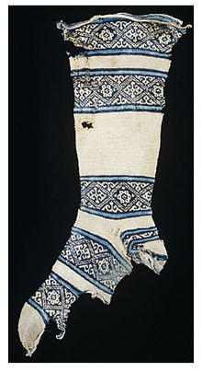
12 th-century cotton sock, found in
Egypt
. The knitter of this sock
started work at the toe and then worked up towards the leg.
The heel was made last and then attached to loops formed while
knitting the leg. This practice allowed the heel to be easily replaced
when it wore out.
So based onthe above account. I personally cannot rule out that striped socks did not exist
Before 1740..that really is absurd from my point of view.. I looked up the History
of socks and found several web sites that cover the history of socks. Considering
The invention of a knitting machine in 1589 meant that socks could be knitted six times
faster than by hand and in many designs and colors.
A couple of the webs sites eye had check do mention stripped socks after the knitting machine was invented.
However eye will say that ~ that style was probably not as common as well as the type of sock that were
embroidered with personal emblems to fashionably identify ones personal socks. Another note is that pirates of the GAOP were still just people like you and eye and had fashionable taste. No one wears exactly the same clothing now any more than they did back then. There was a variety of styles and fashions of clothing/socks available to wear.
So just maybe..maybe one pirate did in fact wear a pair of stripey socks that is so popular in todays cultural portrayal of pirates of the GAOP. But again it is still debatable... because unlike the other web sites eye checked . ~
"At the very end of the century (1790s) very fancy striped stockings become fashionable; with the exception of a possible example worn by a sailor in a mid-18th c. illustration, striped stockings don't seem to have been common before the end of the 18th century. Ribbed stockings, however, were worn." This is from the web site salt pots posted.
Edited May 10, 2012 by oderlesseye

- Quote
- Edit
- Options

Capt. Sterling
- Sticky Fingers Sterling Needs a New Hat
- Member

- 10,302 posts
- Gender:Pyrate Hunter
- Location:here
- Interests:Killing pirates, haven't met one yet worth keeping alive....
(IP: 65.160.148.76) · ·
Posted May 10, 2012 (edited) · Report post
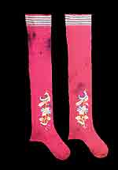
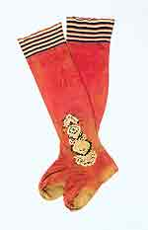both dated as 17th century Found: http://www.german-ho...schichte_09.htm
but then this only shows the very cuff of the stocking so it does not support the all over stripe. Still looking for the link to the site these were posted on.
Next pair
found: http://educators.mfa...=41&pageSize=80
Museum of Fine Arts, Boston
The Elizabeth Day McCormick Collection
Accession number: 43.1943a-b
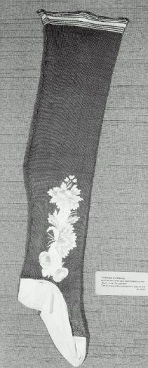
Edited May 10, 2012 by Capt. Sterling

- Quote
- Edit
- Options

Capt. Sterling
- Sticky Fingers Sterling Needs a New Hat
- Member

- 10,302 posts
- Gender:Pyrate Hunter
- Location:here
- Interests:Killing pirates, haven't met one yet worth keeping alive....
(IP: 65.160.148.76) · ·
Posted May 10, 2012 (edited) · Report post
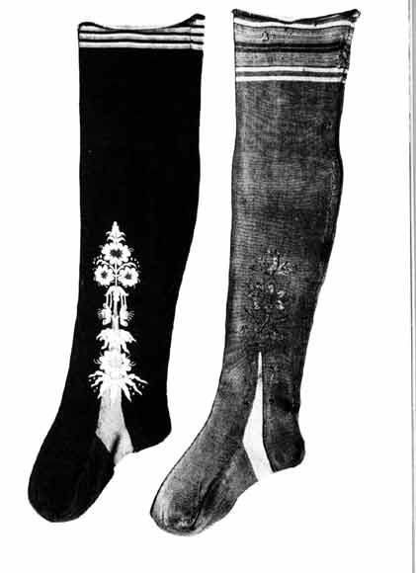
Machine knit, c. 1720
Found: http://www.german-ho.../Bild10_06a.htm
Make note: most of the striped cuff stockings I am coming across are Italian or German, not English, or Colonial. They are also silk. So some stripes, but nothing all over in the 17th century or early 18th century as of yet.
Edited May 10, 2012 by Capt. Sterling

- Quote
- Edit
- Options

Capt. Sterling
- Sticky Fingers Sterling Needs a New Hat
- Member

- 10,302 posts
- Gender:Pyrate Hunter
- Location:here
- Interests:Killing pirates, haven't met one yet worth keeping alive....
(IP: 65.160.148.76) · ·
Posted May 10, 2012 · Report post
Unfortunately even if it was fashionable in the late 18th century doesn't mean it was even common in the early 18th century.

• • Quote
• Edit
• Options

Swashbuckler 1700
- Dread Pyrate
- Member

- 1,115 posts
- Gender:Male
- Location:Europe
- Interests:pyrates, pryvateers, naval military and other history, different books, good movies, music (a little bit), drawing, games,...
(IP: 80.223.160.249) · ·
Posted May 10, 2012 · Report post
On 5/10/2012 at 10:13 AM, Capt. Sterling said:
Machine knit, c. 1720
Found: http://www.german-ho.../Bild10_06a.htm
Make note: most of the striped cuff stockings I am coming across are Italian or German, not English, or Colonial. They are also silk. So some stripes, but nothing all over in the 17th century or early 18th century as of yet.
Here are similar ones in 1720

On 4/17/2009 at 5:03 PM, Gentleman of Fortune said:
1740
I think that is just the way of coloring things with stripes so popular in the period note e.g the landscape is colored with the stripes.

- Quote
- Edit
- Options

Hawkyns
- Curmudgeon With A Cannon
- Moderator

- 1,330 posts
- Gender:Male
- Location:New Haven Colony
- Interests:cannon, swords, cannon, wenches, cannon, muskets, cannon, pistols, cannon, re-enacting, cannon, rum, cannon, living history......... Did I mention cannon?
(IP: 75.9.132.105) · ·
Posted May 10, 2012 · Report post
Is there any possibility that those stripes at the top are a stretchy stitch, like garter stitch, to aid in holding them up?
Hawkyns

- Quote
- Edit
- Options

jendobyns
- Pyrate Captain
- Member

- 562 posts
- Gender:Female
- Location:Baltimore
- Interests:too numerous to mention, really. Period foodways, baroque dance, material culture, etc., etc.
(IP: 72.81.199.132) · ·
Posted May 10, 2012 · Report post
On 5/10/2012 at 7:22 PM, Hawkyns said:
Is there any possibility that those stripes at the top are a stretchy stitch, like garter stitch, to aid in holding them up?
Hawkyns
That was what I was trying to get to on the other thread. Could be a structural thing, but without examining the garments themselves, how can we tell?
Hmmm, will to see if they show up in any of the new books I brought home from Ft. Fred and haven't read thoroughly. Could take a bit, they're on the other floor and I'm on one leg at the moment.

- Quote
- Edit
- Options

jendobyns
- Pyrate Captain
- Member

- 562 posts
- Gender:Female
- Location:Baltimore
- Interests:too numerous to mention, really. Period foodways, baroque dance, material culture, etc., etc.
(IP: 72.81.199.132) · ·
Posted May 10, 2012 · Report post
Nope, no details in the books upstairs. However, I did ask about this last summer at one of the CW tailoring weekends when someone on this forum asked me, and either Neal or Mark said stripes aren't appropriate. And since they cover Jamestown as well as CW, it's not like their info is OOP.

- Quote
- Edit
- Options

peglegstrick
- Dread Pyrate
- Member

- 1,203 posts
- Gender:Male
- Location:Funston Ga
(IP: 71.31.122.148) · ·
Posted May 11, 2012 · Report post
might they be a lether garter? on the fig 18 picture the guy in the chair's stockings flair out at the top.

- Quote
- Edit
- Options

Capt. Sterling
- Sticky Fingers Sterling Needs a New Hat
- Member

- 10,302 posts
- Gender:Pyrate Hunter
- Location:here
- Interests:Killing pirates, haven't met one yet worth keeping alive....
(IP: 67.237.182.13) · ·
Posted May 11, 2012 · Report post
Odds are there is some sort of garter whether leather, silk or some other type of cord...and his stockings are pulled up over the knees of his breeches, a popular style at the time, and not tucked under the ends. I wear my stockings in such a way and get exactly the same look.

- Quote
- Edit
- Options

peglegstrick
- Dread Pyrate
- Member

- 1,203 posts
- Gender:Male
- Location:Funston Ga
(IP: 71.31.122.148) · ·
Posted May 11, 2012 · Report post
I don' use but one stocking but I do use a leather garter w/buckle to keep it up.....can't say that i'm period correct though...really not trying to be period correct though .....because I'm using a modern socket on my pegleg. Scared to try a period one...looks like they would hurrt like hell.

- Quote
- Edit
- Options

Capt. Sterling
- Sticky Fingers Sterling Needs a New Hat
- Member

- 10,302 posts
- Gender:Pyrate Hunter
- Location:here
- Interests:Killing pirates, haven't met one yet worth keeping alive....
(IP: 65.160.148.76) · ·
Posted May 11, 2012 · Report post
On 5/10/2012 at 7:22 PM, Hawkyns said:
Is there any possibility that those stripes at the top are a stretchy stitch, like garter stitch, to aid in holding them up?
Hawkyns
Good questions, was reading a quick bit about ribbed cuffs to help hold them up, will go back and see if that has an answer and what the actual dates were for that section.

- Quote
- Edit
- Options

Grymm
- First Mate
- Member

- 281 posts
- Gender:Male
- Location:Chilterns UK
- Interests:Stuff
(IP: 109.157.207.185) · ·
Posted May 11, 2012 (edited) · Report post
Vertical striped stockings are in fashion for the Macaroni/Incroyable types at the end of the 18thC
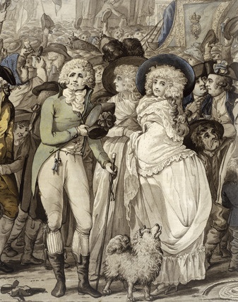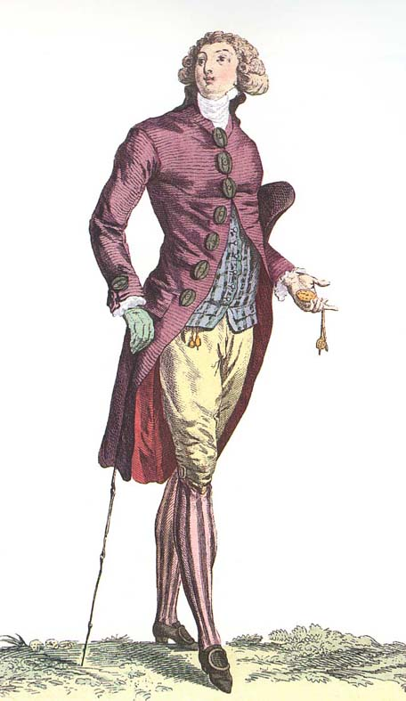
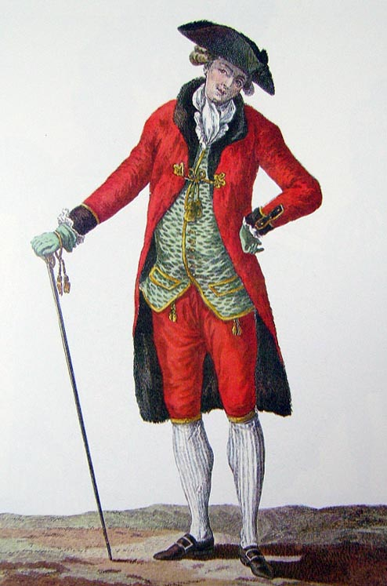
Prob'ly frame knitted and silk as these chaps are Dandies..
The 'motley' as worn by landsknecht types in the 16thc, like this blokey doing nasty things to St Catherine here
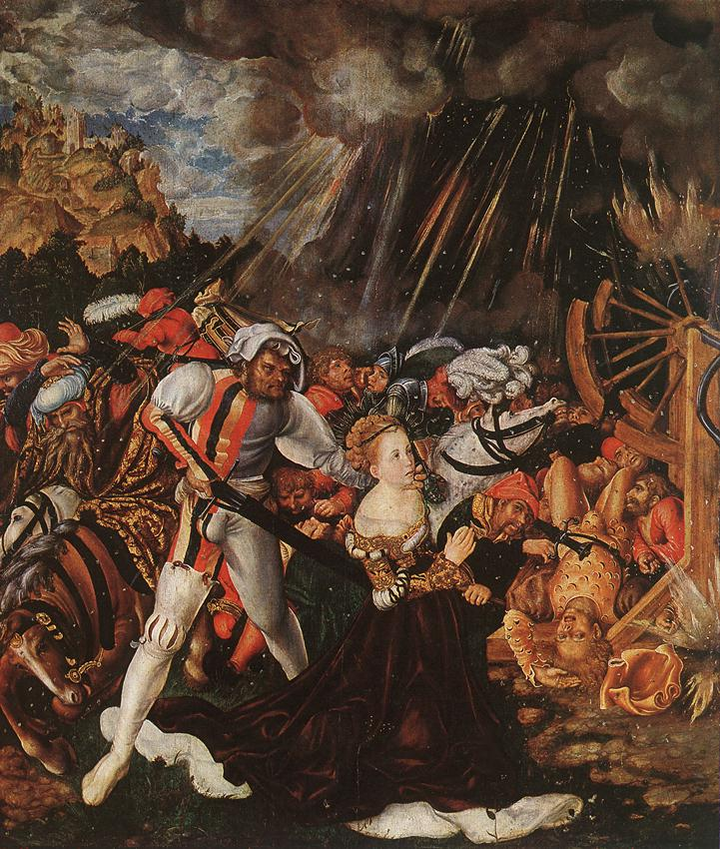
is made of bias cut cloth sewn together and a right pain to do and to get it to fit closely to the leg, especially with knackered steel pinned ankles like mine.
=o)
You do get hoops on some fancy boothose from the early 17thC (1640's)
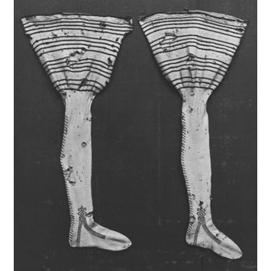
And the hooped pair here are 1860s
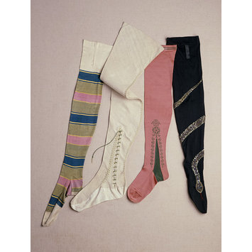But as yet I've not found any for the late 17th or early 18thC
Edited May 11, 2012 by Grymm

- Quote
- Edit
- Options

oderlesseye
- Scourge o' the 7 Seas
- Member

- 2,126 posts
- Gender:Male
- Location:San Diego, Ca. (North Park) me cove !
- Interests:Oderlesseye is a mutinous two bit sand dollar with a thirst for adventure. Sailing on tall ships, firing black powder weapons, and sword fighting.. I most love to entertain the public in piratical skit presentations that involve all of the above. My name is befitting of my position on board as that of the look-out. Some ask what’s the meaning of the name Oderlesseye...It is simple really.. When Eye am aloft, ye can’t smell me...But it’s spelled wrong some exclaim! Hey now! What pirate can spell? - is my retort!
I have been an active member of the pirate community since 2005. I consider myself a fan of living history in the Golden Age of Piracy. As a child I , like the lot of ye, loved the old time pirate movies with Errol Flynn and Douglas Fairbanks. Long live Long John Silver !
Inspired by them, Eye created a Pirate Ninja Movie called "Treachery and a Dead Mans Promise" Available on YouTube.
Being a pirate, as it turns out, is multi-dimensional. For me, a lifestyle has been carved out of it. There is a six foot tall skeleton pirate in a make shift hide out called Dead Mans Cove behind my house. The walls are painted giving the impression you are in a sea cave. There is a mural of a pirate coming ashore in a long boat at the mouth of the cove. Believe me, it is a great place to enjoy rum now and again!
Exploration into all things piratical have led me to being an attempted escapee from the Governors noose to impersonating a judge in the Anne Bonnie and Mary Read trial held in Pirates In Paradise.. As Oderlesseye, my one on one impression to patrons is as one whom barley escaped the flames of the ship we took when the powder magazine blew with the booty in me hands from the Captains quarters.. The tale explains the soot on me face, the tattered clothing, and the burnt tricorn, as I hand out a gold coin or two. I hate them plastic ones and I know kids appreciate the metal coins even more so.
When an event is slated for a historical time line presentation to the public, I do not do these things mentioned above. Rather, I share about what is a grape shot or how a flintlock works. I ware clothing that is more closely representing the era in these cases. I am still updating me togs (Period Kit) as I learn more thru fellow pirates and sources like the Pyracy Pub.
So far, there have been many exciting moments of adventure the world of PIRACY has afforded me. From standing on a bar top with Pirates Charles singing to me in New Orleans to shooting cannons ( Ships Guns for you PC Pirates!), on the tall ship Spirit of Dana Point. Cheers from a crowd during a show as last man standing on the Treasure chest proclaiming to an excited crowd ITS MINE! THE BOOTY IS MINE ! YARR ! ~ These things and the notoriety that comes with being a pirate has me hooked! Whats More Is the greater bonds of friendships that have been forged with those whose course finds me at such events, sharing the same love and passion of the Life within the pirate/reenactment community. To Them Eye take me hat off and offer a tot of Rum! Cheers mates!
(IP: 72.220.190.137) · ·
Posted May 17, 2012 (edited) · Report post
This web site claims Striped socks existed in the 1600's
http://www.ravelry.c...riped-stockings
The Sock Museum is here ~
http://www.sockmuseum.com/socks/striped-stockings
Edited May 17, 2012 by oderlesseye

- Quote
- Edit
- Options

Mission
- Goat Specialist
- Admin

- 5,082 posts
- Gender:Male
- Location:Monroe, MI
- Interests:Scholarly piracy, designing and creating haunted house rooms and props, movies, abstract thinking, abstruse thinking, obstructive thinking, ideating, random thinking, movies, cartoons, movies, movies scores, cycling, world peace and small furry dogs, movies, writing, drawing, personal skills training, gremlins and, of course, lest I forget, movies.
(IP: 24.247.94.112) · ·
Posted May 18, 2012 (edited) · Report post
Is the question whether striped socks existed during the GAoP (1690-1725)? It seems like as much a question of fashion as it is of existance - if they weren't in fashion, few, if any, people would wear them.
By way of example, parachute pants exist, but how many people do you see wearing them these days?
Edited May 18, 2012 by Mission

- Quote
- Edit
- Options

michaelsbagley
- Smells Like Wet Sheep
- Moderator

- 2,548 posts
- Gender:Male
- Location:Columbus, Ohio
- Interests:Mostly into GAoP, but starting to develop more Buccaneer era stuff for re-enacting as well. Generally I do re-enact both piratical/nautical and other impressions from the period. I am focusing on more "common" impressions from the period (i.e. average sailor/pirate, rank and file Red Coat, early Colonial huntsman, etc.)
(IP: 174.231.1.122) · ·
Posted May 18, 2012 (edited) · Report post
Another point to bring up, is that both of those links are to private web site and have no citations. It's the equivalent of saying something existed because so-and-so said it on their blog. Had either of the authors of the web sites included some bibliographical reference, or anything more solid to base that assertion on, cool... but right now it reads like we say so because we heard it somewhere, so it must be true.
Positive proof backed by solid references is one of the accepted norms for historical interpretation.
Edited May 18, 2012 by michaelsbagley

- Quote
- Edit
- Options

oderlesseye
- Scourge o' the 7 Seas
- Member

- 2,126 posts
- Gender:Male
- Location:San Diego, Ca. (North Park) me cove !
- Interests:Oderlesseye is a mutinous two bit sand dollar with a thirst for adventure. Sailing on tall ships, firing black powder weapons, and sword fighting.. I most love to entertain the public in piratical skit presentations that involve all of the above. My name is befitting of my position on board as that of the look-out. Some ask what’s the meaning of the name Oderlesseye...It is simple really.. When Eye am aloft, ye can’t smell me...But it’s spelled wrong some exclaim! Hey now! What pirate can spell? - is my retort!
I have been an active member of the pirate community since 2005. I consider myself a fan of living history in the Golden Age of Piracy. As a child I , like the lot of ye, loved the old time pirate movies with Errol Flynn and Douglas Fairbanks. Long live Long John Silver !
Inspired by them, Eye created a Pirate Ninja Movie called "Treachery and a Dead Mans Promise" Available on YouTube.
Being a pirate, as it turns out, is multi-dimensional. For me, a lifestyle has been carved out of it. There is a six foot tall skeleton pirate in a make shift hide out called Dead Mans Cove behind my house. The walls are painted giving the impression you are in a sea cave. There is a mural of a pirate coming ashore in a long boat at the mouth of the cove. Believe me, it is a great place to enjoy rum now and again!
Exploration into all things piratical have led me to being an attempted escapee from the Governors noose to impersonating a judge in the Anne Bonnie and Mary Read trial held in Pirates In Paradise.. As Oderlesseye, my one on one impression to patrons is as one whom barley escaped the flames of the ship we took when the powder magazine blew with the booty in me hands from the Captains quarters.. The tale explains the soot on me face, the tattered clothing, and the burnt tricorn, as I hand out a gold coin or two. I hate them plastic ones and I know kids appreciate the metal coins even more so.
When an event is slated for a historical time line presentation to the public, I do not do these things mentioned above. Rather, I share about what is a grape shot or how a flintlock works. I ware clothing that is more closely representing the era in these cases. I am still updating me togs (Period Kit) as I learn more thru fellow pirates and sources like the Pyracy Pub.
So far, there have been many exciting moments of adventure the world of PIRACY has afforded me. From standing on a bar top with Pirates Charles singing to me in New Orleans to shooting cannons ( Ships Guns for you PC Pirates!), on the tall ship Spirit of Dana Point. Cheers from a crowd during a show as last man standing on the Treasure chest proclaiming to an excited crowd ITS MINE! THE BOOTY IS MINE ! YARR ! ~ These things and the notoriety that comes with being a pirate has me hooked! Whats More Is the greater bonds of friendships that have been forged with those whose course finds me at such events, sharing the same love and passion of the Life within the pirate/reenactment community. To Them Eye take me hat off and offer a tot of Rum! Cheers mates!
(IP: 72.220.190.137) · ·
Posted May 18, 2012 (edited) · Report post
Quote
Had either of the authors of the web sites included some bibliographical reference
It crossed my mind to ask for their references as it seemed stated that stripey socks were popular
during the years of GAOP . However with out any substantiation to provide any historic proof.. Therefore Eye
do conclude that it would have been a most rare thing for a Pirate of the GAOP to wear stripey socks.
Eye have been unable to find proof as much as my heart would like. Therefore eye will side with you that they most likely
did not exsist. One thing eye will say going down this road is that this wreaks of Agnosticism at its best.
Eye did -e- mail the one web site and await an answer from them..this is what eye wrote to the 'Sock Museum"
"As A member of the reenactment community that portrays pirates, We have been unable to substantiate your claims to stripey socks being period to Pirates of the Golden age of Piracy. 1630-1720's . We are interested in your historical references you used to make these claims. Thank you."
Edited May 18, 2012 by oderlesseye

- Quote
- Edit
- Options

Ivan Henry aka Moose
- Plunderer
- Member

- 486 posts
- Gender:Male
- Location:tampa, fl
- Interests:Bicycles
Travel
Wine
Beer
Good Food
Pizza!
Pirate Stuff
Design
(IP: 173.78.137.76) · ·
Posted May 23, 2012 · Report post
Not GAOP but of note... Mid 1700s - John Collet

- Quote
- Edit
- Options

jendobyns
- Pyrate Captain
- Member

- 562 posts
- Gender:Female
- Location:Baltimore
- Interests:too numerous to mention, really. Period foodways, baroque dance, material culture, etc., etc.
(IP: 72.81.199.132) · ·
Posted May 24, 2012 · Report post
The thing to note here is the direction of the stripes. Not sure if the artist is taking some license here by adding color or not. Otherwise, this can be done as a sort of ribbed knitting pattern.

- Quote
- Edit
- Options

oderlesseye
- Scourge o' the 7 Seas
- Member

- 2,126 posts
- Gender:Male
- Location:San Diego, Ca. (North Park) me cove !
- Interests:Oderlesseye is a mutinous two bit sand dollar with a thirst for adventure. Sailing on tall ships, firing black powder weapons, and sword fighting.. I most love to entertain the public in piratical skit presentations that involve all of the above. My name is befitting of my position on board as that of the look-out. Some ask what’s the meaning of the name Oderlesseye...It is simple really.. When Eye am aloft, ye can’t smell me...But it’s spelled wrong some exclaim! Hey now! What pirate can spell? - is my retort!
I have been an active member of the pirate community since 2005. I consider myself a fan of living history in the Golden Age of Piracy. As a child I , like the lot of ye, loved the old time pirate movies with Errol Flynn and Douglas Fairbanks. Long live Long John Silver !
Inspired by them, Eye created a Pirate Ninja Movie called "Treachery and a Dead Mans Promise" Available on YouTube.
Being a pirate, as it turns out, is multi-dimensional. For me, a lifestyle has been carved out of it. There is a six foot tall skeleton pirate in a make shift hide out called Dead Mans Cove behind my house. The walls are painted giving the impression you are in a sea cave. There is a mural of a pirate coming ashore in a long boat at the mouth of the cove. Believe me, it is a great place to enjoy rum now and again!
Exploration into all things piratical have led me to being an attempted escapee from the Governors noose to impersonating a judge in the Anne Bonnie and Mary Read trial held in Pirates In Paradise.. As Oderlesseye, my one on one impression to patrons is as one whom barley escaped the flames of the ship we took when the powder magazine blew with the booty in me hands from the Captains quarters.. The tale explains the soot on me face, the tattered clothing, and the burnt tricorn, as I hand out a gold coin or two. I hate them plastic ones and I know kids appreciate the metal coins even more so.
When an event is slated for a historical time line presentation to the public, I do not do these things mentioned above. Rather, I share about what is a grape shot or how a flintlock works. I ware clothing that is more closely representing the era in these cases. I am still updating me togs (Period Kit) as I learn more thru fellow pirates and sources like the Pyracy Pub.
So far, there have been many exciting moments of adventure the world of PIRACY has afforded me. From standing on a bar top with Pirates Charles singing to me in New Orleans to shooting cannons ( Ships Guns for you PC Pirates!), on the tall ship Spirit of Dana Point. Cheers from a crowd during a show as last man standing on the Treasure chest proclaiming to an excited crowd ITS MINE! THE BOOTY IS MINE ! YARR ! ~ These things and the notoriety that comes with being a pirate has me hooked! Whats More Is the greater bonds of friendships that have been forged with those whose course finds me at such events, sharing the same love and passion of the Life within the pirate/reenactment community. To Them Eye take me hat off and offer a tot of Rum! Cheers mates!
(IP: 72.220.190.137) · ·
Posted May 24, 2012 · Report post
Eye just got a book called "The Chronicle of Western Costume" by John Peacock
On page 105 it clearly shows an illustration of an Englishman in 1600 wearing stripey socks, Horizontal
like the ones eye wore in the "You and Your Garb" thread. Again..NO real evidence to support whether the
author or artist took licence or not. All the other illustrations show no Stripey socks what so ever During GAOP. (1670 -1730)
In 1670 June 1st
English king Charles II and French king Louis XIV sign anti-Dutch treaty
..We all know what that lead to.. And 1671 January 18 "Pirate" Henry Morgan defeats Spanish defenders, captures Panama January 27 "Pirate" Henry Morgen lands at Panama City

- Quote
- Edit
- Options

jendobyns
- Pyrate Captain
- Member

- 562 posts
- Gender:Female
- Location:Baltimore
- Interests:too numerous to mention, really. Period foodways, baroque dance, material culture, etc., etc.
(IP: 72.81.199.132) · ·
Posted May 27, 2012 · Report post
Well, sure, it's not evidence of their actual existence in the time period. It's a costume book by a theatrical costumer, and therefore evidence of someone's imagination and creativity within a historic framework. Actual evidence comes from primary sources in the form of artifact (an item that can be dated to the time), written description by someone who lived at the time, or artwork of the period (not illustrating the period, but by an artist _from_ that time period) when it is clear the artist isn't taking too much license with the subject. Art work can be tricky that way, and it's necessary to be aware of fashion trends in art work, too.
You can do much better if you are looking for historic clothing books. Not as cheap, but you usually get what you pay for in these cases.
Jen

- Quote
- Edit
- Options

Swashbuckler 1700
- Dread Pyrate
- Member

- 1,115 posts
- Gender:Male
- Location:Europe
- Interests:pyrates, pryvateers, naval military and other history, different books, good movies, music (a little bit), drawing, games,...
(IP: 80.223.160.249) · ·
Posted June 28, 2012 · Report post
What about checkered stockings used by Scottish... Paterned stockings at least....
Here 1746 painting but I know earlier pictures of the Scottish with checkered stockings
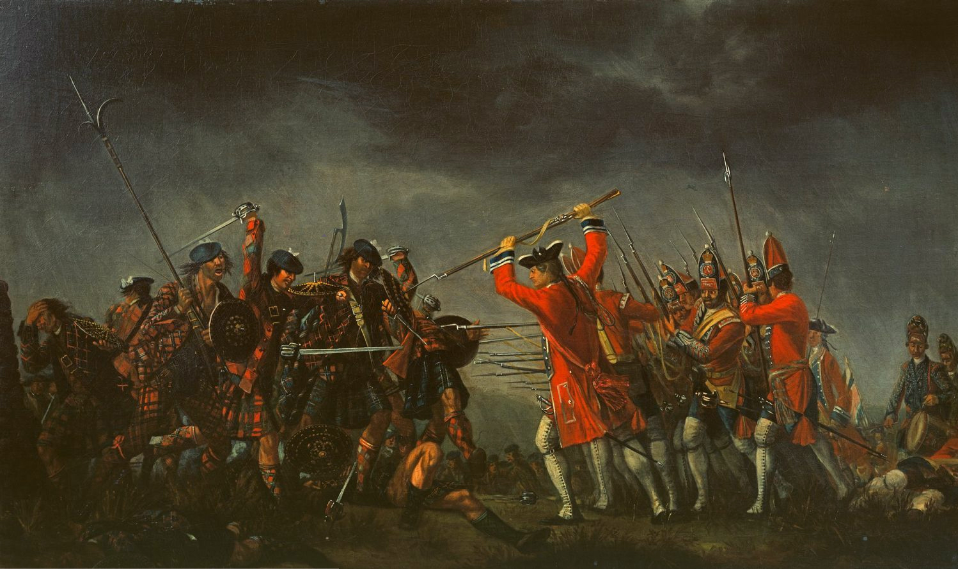

- Quote
- Edit
- Options

Grymm
- First Mate
- Member

- 281 posts
- Gender:Male
- Location:Chilterns UK
- Interests:Stuff
(IP: 86.173.254.105) · ·
Posted June 28, 2012 · Report post
Cloth bag hose, cross/bias cut cloth, to give some stretch, in tartan. Prob'ly seamed up the back like muddyevil hose with a seperate vamp and sole.

• Quote
• Edit
• Options

